Unit 4 - Worksheet 8

Multiple Object Systems

In each of the following situations, start by drawing a system schema for the situation. Identify each single object as a separate system, and draw force diagrams for each system. Identify a larger system as in the class discussion where all the parts act as one, illustrate the ‘megadot’ system on the system schema, then draw a single force diagram for the entire megadot system.

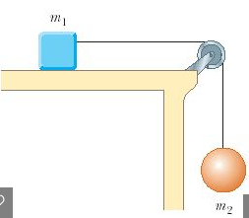

1. A block rests on a table, and is pulled by a string, attached to a ball hanging over the side of the table.

|  |  |  |
| --- | --- | --- |
| a. System schema for box (m1): | b. System schema for ball (m2): | c. System schema for “megadot”: |
| d. Force diagram for box: | e. Force diagram for ball: | f. Force diagram for “megadot”: |

g. If the box has a mass of 10 kg, and the ball has a mass of 1 kg, determine the **force of friction** acting on the box to hold it in place.

2. Two blocks are hung from a pulley as shown to the left. Block ‘M’ rests on a table, while block ‘m’ is suspended in mid-air.

|  |  |  |
| --- | --- | --- |
| a. System schema for box ‘M’: | b. System schema for box ‘m’: | c. System schema for “megadot”: |
| d. Force diagram for box ‘M’: | e. Force diagram for box ‘m’: | f. Force diagram for “megadot”: |

g. If block ‘M’ has a mass of 20 kg, and block ‘m’ has a mass of 5 kg, determine the perpendicular force acting on block ‘M’.

h. If block ‘m’ had a mass of 10 kg, what would the value of the perpendicular force on block ‘M’ be?

i. How much mass would block ‘m’ have to have such that block ‘M’ experienced a perpendicular force equal to 0 Newtons?